

**CLOUD BASED ATTENDANCE FOR STUDENTS/EMPLOYEES USING CNN AND LSTM**

##### PROJECT REPORT

###### ***Submitted by***

##### SURENDAR.G [REGISTER NO:211417104275]

**VASANTH.S[REGISTER NO:211417104294]**

**VISHNU.J[REGISTER NO:211417104304]**

***in partial fulfillment for the award of the degree***

***of***

**BACHELOR OF ENGINEERING**

IN

# COMPUTER SCIENCE AND ENGINEERING

PANIMALAR ENGINEERING COLLEGE, CHENNAI-600123.

ANNA UNIVERSITY: CHENNAI 600 025

##### APRIL 2021

**BONAFIDE CERTIFICATE**

Certified that this mini project report **“CLOUD BASED ATTENDANCE FOR STUDENTS/EMPLOYEES USING CNN AND LSTM”**is the bonafide work of “**SURENDAR.G(211417104275)**,**VASANTH.S(211417104294) and VISHNU.J**

**(211417104304)”** who carried out the project work under my supervision.

**SIGNATURE SIGNATURE**

**Dr.S.MURUGAVALLI,M.E.,Ph.D., Mr.A.N.SASIKUMAR**

**HEAD OF THE DEPARTMENT Professor**

DEPARTMENT OF CSE, DEPARTMENT OF CSE,

PANIMALAR ENGINEERING COLLEGE, PANIMALAR ENGINEERING COLLEGE,

NAZARATHPETTAI, NAZARATHPETTAI,

POONAMALLEE, POONAMALLEE,

CHENNAI-600 123. CHENNAI-600 123.

Certified that the above candidate(s) were examined in the Anna University Project Viva-Voce Examination held on...........................

**INTERNAL EXAMINER EXTERNAL EXAMINER**

**ACKNOWLEDGEMENT**

We express our deep gratitude to our respected Secretary and Correspondent **Dr.P.CHINNADURAI, M.A., Ph.D.** for his kind words and enthusiastic motivation, which inspired us a lot in completing this project.

We would like to extend our heartfelt and sincere thanks to our Directors **Tmt.C.VIJAYARAJESWARI**, **Thiru.C.SAKTHIKUMAR,M.E.,** and **Tmt. SARANYASREE SAKTHIKUMAR B.E.,M.B.A.,** for providing us with the necessary facilities for completion of this project.

We also express our gratitude to our Principal **Dr.K.Mani, M.E., Ph.D.** for his timely concern and encouragement provided to us throughout the course.

We thank the HOD of CSE Department, **Dr. S.MURUGAVALLI , M.E.,Ph.D.,** for the support extended throughout the project.

We would like to thank my Project Guide , **Mr.A.N SASIKUMAR M.E.,(P.hD).,** and all the faculty members of the Department of CSE for their advice and suggestions for the successful completion of the project.

We would also like to thank our parents and our friends who helped us in the progress of the project.

**NAME OF THE STUDENTS**

**SURENDAR.G**

**VASANTH.S**

**VISHNU.J**

|  |  |
| --- | --- |
|  |  |
|  |  |

**ABSTRACT**

A facial recognition attendance system is a contactless way to manage visitors and employees in an organization. Unlike other types of biometric systems, such as fingerprints that capture identity through touch, a facial recognition system is a touchless way to manage employees and visitors. In this Virtual Era Institute’s and Corporates are moving towards e-learning and e-training facilities where attendance plays a vital role. Having time constraints as a limit, a lot of time is wasted in taking attendance. In this project we have come with an idea of an automated attendance system and head-count during any live session or at the entrance. There will be no manual work of taking attendance after the implementation of this system. As soon as the users enter the session the attendance will be marked with the time stamp. The head count will be taken in random duration to prevent flaws and attendance will be verified on change of headcount. The Attendance data will be stored in an SQL database and propagated to the website which will be available for the instructor or admin user for cross verification. The Main Objective of this project is to reduce the burden/Work that is carried out manually for taking attendance by replacing it with a Smart attendance system using Facial Recognition. It takes barely 3 seconds to recognize your face and create an attendance journal in the payroll system, saving precious man-hours. Automatically scans multiple students, with 99.8% accuracy in face detection. Faces once recognised are accurately enrolled into the payroll system. Integrated with systems like loT sensors, it cannot be scammed easily. Saving time will lead to an increase in productivity, resulting in reduction of cost (optimal utilization of resources) and an increase in revenue

**KEYWORDS: Deep Learning, Cloud computing( Flask ), web development, image processing, AI, port sharing, SSH , OBS Studio, collaboration with Zoom, Teams and G-Meet.**

**TABLE OF CONTENTS**

|  |  |  |
| --- | --- | --- |
| **CHAPTER NO.** | **TITLE** | **PAGE NO.** |
|  | **ABSTRACT** | iii |
|  | **LIST OF FIGURES** | vi |
| **1.** | **INTRODUCTION** | 1 |
| **2.** | **LITERATURE SURVEY** | 4 |
| **3.** | **SYSTEM ANALYSIS** | 9 |
|  | 3.1 Existing System | 10 |
|  | 3.2 Proposed system | 10 |
|  | 3.3 Requirement Analysis and Specification | 11 |
|  | 3.4 Hardware Environment | 11 |
| **4.** | **SYSTEM DESIGN** | 13 |
|  | 4.1. Architecture Diagram  4.2 ER Diagram | 14 |
| **5.** | 4.3 Data Flow / Block Diagram  4.4 Use Case Diagram  **ALGORITHM AND MODEL DESCRIPTION** | 19 |
|  | 5.1 CNN based Training | 23 |
|  | 5.2 Exporting the Model to cloud | 24 |
|  | 5.3 Using Dlib and Cmake for system compatibility  5.4 Connecting the cloud using Flask | 25 |
| **6.** | **SYSTEM IMPLEMENTATION** | 26 |
|  | 6.1 coding-Model Training    6.2 coding-Server side Scripting    6.3 coding-Dlib and Cmake script  6.4. Coding HTML and Flask Script. |  |
| **7.** | **SYSTEM TESTING** |  |
|  | 7.1 Performance Analysis | 50 |
| **8.** | **CONCLUSION** | 56 |
|  | 8.1 Conclusion  8.2 Future scope | 57 |
|  | **APPENDICES** | 58 |
|  | A.1 Sample Screenshots | 59 |
|  |  |  |
|  | **REFERENCES** | 63 |
|  |  |  |
|  |  |  |
|  |  |  |
|  |  |  |
|  |  |  |
|  | **LIST OF FIGURES** |  |

**FIGURE DETAILS PAGE NO**

**NO**

4.1 BASE ARCHITECTURE 14

4.2 ER DIAGRAM 15

4.3 DATA FLOW DIAGRAM 18

4.4 USE-CASE DIAGRAM 20

**INTRODUCTION**

**CHAPTER-1**

**INTRODUCTION**

**1.1 OVERVIEW**

Traditional method of attendance marking is a tedious task in many schools and colleges. It is also an extra burden to the faculties who should mark attendance by manually calling the names of students which might take about 5 minutes of the entire session. This is time consuming. There are some chances of proxy attendance. Therefore, many institutes started deploying many other techniques for recording attendance like use of Radio Frequency Identification (RFID), iris recognition, fingerprint recognition, and so on. However, these systems are queue based which might consume more time and are intrusive in nature. Face recognition has set an important biometric feature, which can be easily acquirable and is non-intrusive. Face recognition based systems are relatively oblivious to various facial expressions. Face recognition system consists of two categories: verification and face identification. Face verification is an 1:1 matching process, it compares face

image against the template face images and whereas is an 1:N problem that compares a query face images. The purpose of this system is to build an attendance system which is based on face recognition techniques. Here the face of an individual will be considered for marking attendance. Nowadays, face recognition is gaining more popularity and has been widely used. In this paper, we proposed a system which detects the faces of students from live streaming video of classroom and attendance will be marked if the detected

face is found in the database. This new system will consume less time than compared to traditional methods.

**1.2 PROBLEM DEFINITION**

In this online era the **management of the attendance can be a great burden on the teachers, faculty members and organisations as it's done by hand.** They also face the problem of proxy attendance, maintaining all handwritten documents of student attendance of each batch/class every day. Even though smart and auto attendance management systems like **RFid and biometrics are being utilized, authentication is an important issue in this system.** Face recognition is one of the biometric methods to improve this system. Being a prime feature of biometric verification, facial recognition is being used enormously in several such applications, like video monitoring and CCTV footage systems, an interaction between computers & humans and access systems present indoors and network security. *To resolve this problem, we introduce* **Facial Recognition based Smart Attendance System for Students/Employees.** In this project we build a ***Web Application powered with the help of Amazon EC2 Linux instance.*** By utilizing this Application, the problem of proxies and burden of attendance on faculties and organisations will be solved in ease.

**LITERATURE SURVEY**

**CHAPTER-2**

**LITERATURE SURVEY**

**TITLE:**Face Recognition Attendance System Based on Real-Time Video Processing

**AUTHOR:**HAO YANG AND XIAOFENG HAN

**JOURNALS/MAGAZINES:**IEEE ACCESS

**METHODOLOGY:** DEEP LEARNING

**INFERENCE:** In [1] this paper,the concept of attendance system based on face recognition technology is proposed, and the research on face recognition attendance system based on real-time video processing is carried out using CNN Algorithm With Steps Of Face Recognition, Geometric Feature Method, Subspace Analysis Method ,Neural Network Method And Support Vector Method and the efficiency is about 82%.

**TITLE:**Automated Attendance Systems Using Face Recognition by K-Means Algorithms

**AUTHOR:**[N Palanivel](https://ieeexplore.ieee.org/author/37085595877);[S Aswinkumar](https://ieeexplore.ieee.org/author/37087058726); [J Balaji](https://ieeexplore.ieee.org/author/37085709548)

**JOURNALS/MAGAZINES:**IEEE

**METHODOLOGY:**MACHINE LEARNING

**INFERENCE:**In this paper, a K-means clustering algorithmic rule is employed to research the facial expression. The biometric features of the face unit are extracted and also the K-mean clustering technique is used to cluster the face features. Then, SVM methodology is employed to classify the features of the image. Finally, a report is generated for interpretation.

**TITLE:**Smart Attendance Management System Using Face Recognition

**AUTHOR:**Kaneez Laila Bhatti , Laraib Mughal , Faheem Yar Khuhawar , Sheeraz Ahmed Memon

**JOURNALS/MAGAZINES:**EIA

**METHODOLOGY:**DEEP LEARNING

**INFERENCE:** In this paper[3] ,deep learning techniques to develop this system, The frontend side (client side) which consist of GUI which is based on electron JS and backend side consist of logic and python (server side), an IPC (InterPersonal Communication) bridge is developed to communicate these two stacks. The images captured by the camera are sent to the system for further analysis, the input image is then compared with a set of reference images of each of the students and mark their attendance.

**TITLE:**Face Recognition based smart attendance system using IOT

**AUTHOR:**Sakshi Patel, Prateek Kumar , Shelesh Garg , Ravi Kumar

**JOURNALS/MAGAZINES:**IJCSE

**METHODOLOGY:**IOT,OPENCV,SMTP

**INFERENCE:**In this[4]paper,recognizer library is used for facial recognition and storing attendance. The absentee’s supervisor or parents are informed through email regarding the absence of their employees or wards respectively. The objective of this project is to innovate existing projects with some added feature like large data storage and fast computing through less hardware cost.

**TITLE:**An automated classroom attendance system using video based face recognition

**AUTHOR:**[Anshun Raghuwanshi](https://ieeexplore.ieee.org/author/37086331510); Preeti D Swami

**JOURNALS/MAGAZINES:** IEEE

**METHODOLOGY:** Machine Learning.

**INFERENCE:** This paper[5] proposes and compares the methodologies for an automated attendance system using video-based face recognition. Face recognition is performed and compared on the basis of the accuracy of recognition using Principal Component Analysis (PCA) and Linear Discriminant Analysis (LDA) algorithms.

# TITLE: Cloud based intelligent attendance system through video streaming

**AUTHOR:** [Aayush Mittal](https://ieeexplore.ieee.org/author/37086379837); [Fatima Sartaj Khan](https://ieeexplore.ieee.org/author/37086379733); [Praveen Kumar](https://ieeexplore.ieee.org/author/37085348077); [Tanupriya Choudhury](https://ieeexplore.ieee.org/author/37085794967)

**JOURNAL/MAGAZINES:IEEE**

**METHODOLOGY:** Cloud technology and Face Recognition technique

**INFERENCE:** The system identifies and authenticates each student present in the class. Through this system, the attendance of a group of students is carried out at a single point of time. The objective of the system is to automate the traditional way of taking the attendance on registers and to integrate the system with the cloud so as to make all the records readily available that are maintained by the system by reducing the errors. Thus, when compared with the other alternatives of marking the attendance, this system proves to be more reliable and accurate. Keeping in mind the future scope of making it a commercial product, the system is integrated on a private cloud which can be accessed easily and makes the system more reliable.

**TITLE:** Smart Attendance Management System

**AUTHOR:** Aman Jobanputra, Shubham Jain, Kruttika Choithani

**JOURNALS/MAGAZINES:** IJCST

**METHODOLOGY:** - RFID,Face recognition algorithm

**INFERENCE:** The system allows easy attendance management using the Face Detection, which is one of the most acceptable techniques. The teacher needs to carry a Digital Image Capturing Devices to the lecture room and take a picture of the class. The teacher then needs to log-in to the computer using his/her login credentials. The web page provides a medium to upload the image to the computer. The system has a copy of MATLAB installed in it. System also consists of a database which includes images of all the students and their personal details. The database also keeps records of details of teachers of the respective classes. After the image is uploaded to the system, faces of students are detected from the image using MATLAB software. These images are then compared with the images of students stored in the database using face recognition algorithm and record of attendance is kept. The computer then returns a copy of the html page to the teacher with attendance of each student. But, What if only half the face of a particular student is seen or his face is not clear in the original image. The teacher can manually mark the attendance of those students. This is how the record of attendance is kept in our system.

**SYSTEM ANALYSIS**

**CHAPTER 3**

**SYSTEM ANALYSIS**

**3.1 EXISTING SYSTEM:**

In the existing system , the concept of attendance system based on face recognition technology is proposed, and the research on face recognition attendance system based on real-time video processing is carried out. The algorithm used for face recognition technique i.e. for image classification is CNN(convolutional Neural Network), face feature extraction by LDA method ),the main face recognition methods involves geometric feature method, subspace analysis method, neural network method and support vector machine (SVM) method. Research data shows that the accuracy of the video face recognition system is about 82%.

**3.2 PROPOSED SYSTEM:**

**Prime Objective:**

The Main Objective of this project is to **reduce the burden/Work** that is carried out **manually** for taking attendance by replacing it with a Smart **attendance system using Facial Recognition**.

In this project we build an ***Web Application powered by Amazon EC2*** Linux instance to ***display marked Attendance from the SQL Database****.* The output from the ***conference screen is taken as an input*** for the system. The input screen is converted to ***gray scale and feeded*** to a model trained using ***haarCascade*** to extract facial data sets and head count. The extracted facial dataset is passed to a model trained using ***Convolutional neural network (CNN) having Long short-term memory (LSTM).*** The model is trained With the help of pre-trained data stored in a Key-Value ***pair in MongoDB.*** Once the prediction is done the predicted values are stored in LSTM for future and fast processing. The attendance is ***updated in MySQL*** Database for backend services like ***Flask to fetch and propagate*** in the Admin / staff login portal. This portal allows the instructor to edit and update the attendance entered by the system. ***Performance of the system is increased with encouraging results of initial experiments.*** As a part of ***Fool proof*** when the users enter the session the attendance will be marked with the time stamp. The **head count will be taken in random duration** to prevent flaws and attendance will be verified on change of headcount.

**3.3 REQUIREMENT ANALYSIS:**

**SYSTEM SPECIFICATIONS:**

The system Requirement specification(SRS) document describes all data,functional and behavioural requirements of the software under production or development. System Requirements mentioned below are not most Necessary , the system is designed in a way of functioning with all devices that are comparable in using web browsers. It is produced at the culmination of the analysis task.The software and hardware requirements of this project are listed below,

**3.4 HARDWARE REQUIREMENTS:**

* Processor : core i5/17/i8
* RAM : 4GB
* CPU : 2 x 64-bit 2.8GHZ 8.00 GT/s
* Disk storage : 500 GB

**3.5 SOFTWARE REQUIREMENTS:**

* Cloud Hosting
* Flask
* Python
* Front end (Bootstrap, Html, CSS)

**SYSTEM DESIGN**

**CHAPTER 4**

**SYSTEM DESIGN**

# 4.1 ARCHITECTURE DIAGRAM:

An architectural diagram is a diagram of a system that is used to abstract the overall outline of the software system and the relationships, constraints, and boundaries between components. It is an important tool as it provides an overall view of the physical deployment of the software system and its evolution roadmap. The below

Architecture diagram depicts the overall system implemented in the project.

*I. Base Architecture*

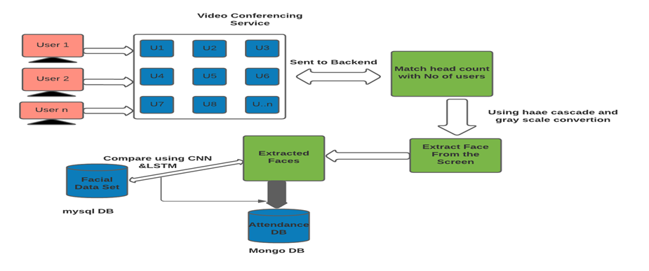

When the user uses the video conferencing service the video is sent to backend which matches the head count with the number of users.Using haar cascade and grey scale conversion face is extracted from the screen and the extracted faces stored in attendance DB (Mongodb) is compared with the facial data set in mySql using CNN and LSTM.

In the above diagram we have shown operations performed in monitoring the class in 8 stages. Firstly with help of OBS we create a virtual can like environment to capture the attendees and provide the input stream to the trained model using Facial datasets of students. The model is trained using CNN and LSTM to get good accuracy with proper results. Haar Cascade is used to identify faces in the screen and to detect the Head count. This system acts as a fool proof by providing a unknown attendance which give a secondary way of judging the system and for manual correction.

*II.**Attendance Tracking page*

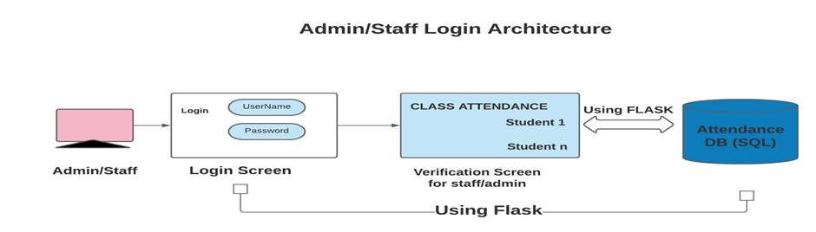

When the admin logins into the attendance screen verification screen for class attendance is opened which are stored in Attendance DB and it is done by using flask, Python library used for developing web applications.

### 

### **4.2 ENTITY -RELATION SHIPS DIAGRAM:**

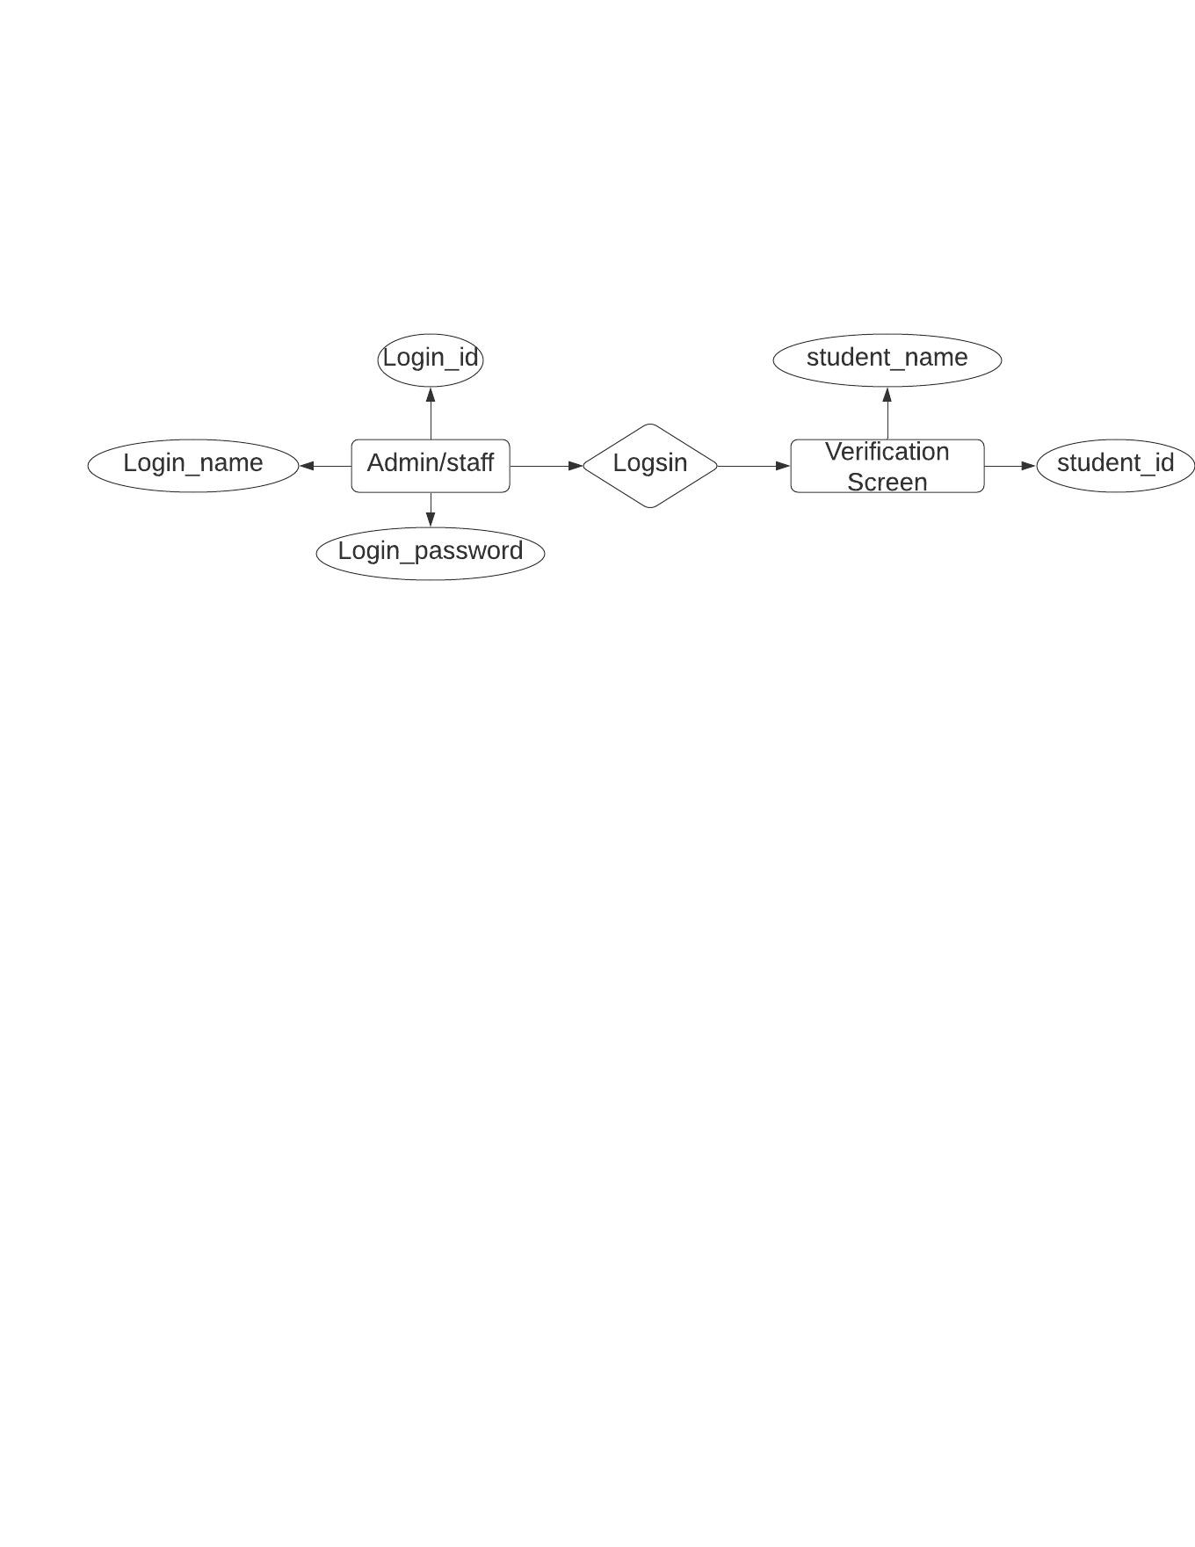

*III. ER Diagram for Admin/staff architecture.*

**Entities:**

Entities are analogous to relations in the relational model. They represent the principle data objects about which information is to be collected. Entities represent concepts or concrete or abstract objects such as person, place, physical things, events. In an E-R diagram, an entity is represented as a named rectangular shape, which may include a list of attributes. For clarity, normally only attributes that are involved in relationships between entities are included, i.e. primary key (PK) and foreign keys (FK). This maintains an uncluttered diagram.

**Relationships:**

A relationship represents some association between two or more entities. In an E-R diagram, a relationship is represented as a diamond shape, containing the name of the relationship between the entities. The ER diagram depicts the admin/staff structure which has the entity Admin/staff containing attributes like login_name, login_password and login_id and the other entity is verification screen containing attributes like student_id or student_name.

### **4.3 DATA FLOW DIAGRAM:**

A data flow diagram is a graphical tool used to describe and analyze movement of data in which the project progressed. In this, the workflow of the project is explained which includes the following steps:

The frames are extracted from the video conference screen using edge detection with the help of matplot library.The output from the conference screen is used as the system's input. To extract facial data sets and count heads, the input screen is converted to grayscale and fed to a model trained with haarCascade. The extracted facial dataset is fed into a Convolutional Neural Network (CNN) model with a long short-term memory (LSTM).

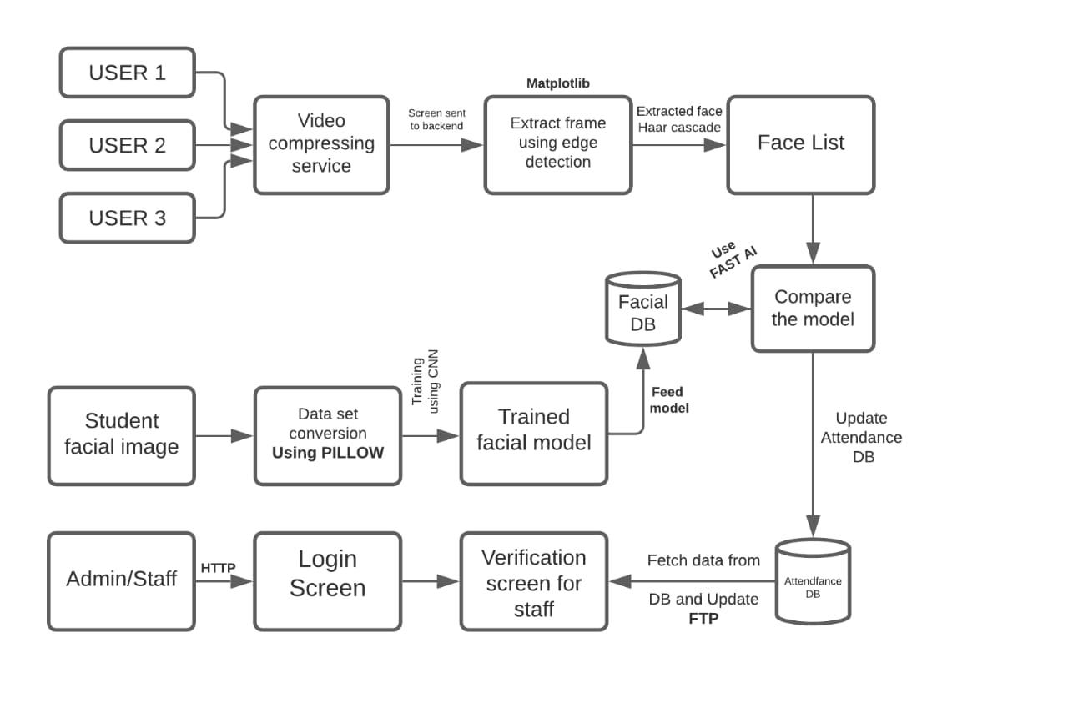

*IV. Data flow/ Block Diagram*

The model is trained using pre-trained data stored in MongoDB as a Key-Value pair. Once the prediction is complete, the predicted values are stored in the LSTM for future use.

The attendance is upgraded in a MySQL database for backend services such as Flask to fetch and propagate in the admin/staff login portal. This portal allows the instructor to edit and update the system's attendance records. The system's performance has improved as a result of promising preliminary results. When users enter the session, their attendance will be recorded with a timestamp as part of Fool proof.

To avoid faults, the head count will be done at random intervals, and attendance will be checked when the headcount changes.

### **4.4 USE CASE DIAGRAM:**

The purpose of the use case diagram is to capture the dynamic aspect of a system. However, this definition is too generic to describe the purpose, as other four diagrams (activity, sequence, collaboration, and Statechart) also have the same purpose. We will look into some specific purpose, which will distinguish it from other four diagrams.

Use case diagrams are used to gather the requirements of a system including internal and external influences. These requirements are mostly design requirements. Hence, when a system is analyzed to gather its functionalities, use cases are prepared and actors are identified. When the initial task is complete, use case diagrams are modelled to present the outside view.

In brief, the purposes of use case diagrams can be said to be as follows −

* Used to gather the requirements of a system.
* Used to get an outside view of a system.
* Identify the external and internal factors influencing the system.
* Show the interaction among the requirements of the actors.

***V.*** *Use case diagram Attendance*

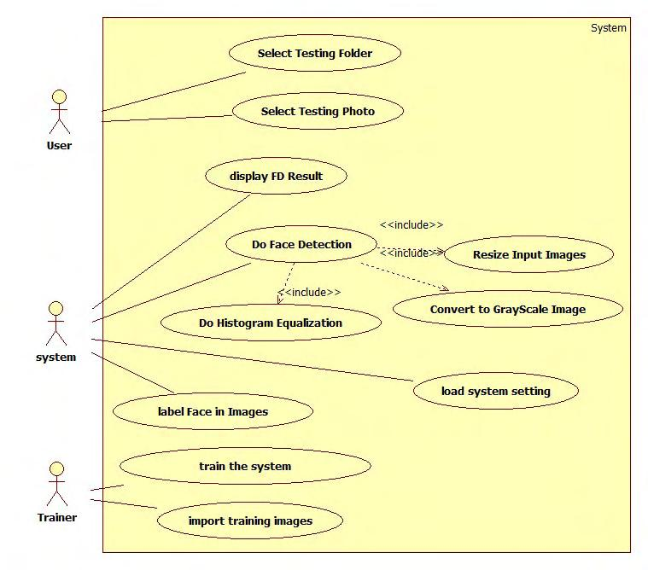

Python Libraries that would be need to achieve the task:

1. Numpy

2. Pandas

3. Sci-kit Learn

4. Matplotlib

5. Seaborn

The project workflow can be explained in following steps,

* Gathering data
* Data cleaning/Data preprocessing
* Researching the model that will be best for the type of data
* Training the model
* Evaluation.

**Gathering Data:**

The process of gathering data depends on the type of project we desire to make. The data set can be collected from various sources such as a file, database, sensor and many other such sources but the collected data cannot be used directly for performing the analysis process as there might be a lot of missing data, extremely large values, unorganized text data or noisy data.We can also use some free data sets which are present on the internet.Kaggle andUCI machine learning repository are the repositories that are used the most for making Machine learning models. Kaggle is one of the most visited websites that is used for practicing machine learning algorithms, they also host competitions in which people can participate and get to test their knowledge of machine learning.In this project we have used self generated Data. This contains student’s or attendees facial images with labels that can be collected from the college/ school Database.

**Data preprocessing/Data cleaning:**

Data cleansing or data cleaning is the process of detecting and correcting (or removing) corrupt or inaccurate [records](https://en.wikipedia.org/wiki/Storage_record) from a record set, [table](https://en.wikipedia.org/wiki/Table_(database)), or [database](https://en.wikipedia.org/wiki/Database) and refers to identifying incomplete, incorrect, inaccurate or irrelevant parts of the data and then replacing, modifying, or deleting the [dirty](https://en.wikipedia.org/wiki/Dirty_data) or coarse data.Therefore, certain steps are executed to convert the data into a small clean data set, this part of the process is called as data pre-processing.In this project, initially, we have 10 image data of our Team Members. In order to avoid data that are repeated fields,

We use data cleanup processes using machine learning models. Data cleaning tasks are done using pandas, Numpy and seaborn libraries.

**Evaluation**

Model Evaluation is an integral part of the model development process. It helps to find the best model that represents our data and how well the chosen model will work in the future.To improve the model we might tune the hyper-parameters of the model and try to improve the accuracy and also looking at the confusion matrix to try to increase the number of true positives and true negatives.

**ALGORITHM AND MODEL**

**DESCRIPTION**

**CHAPTER-5**

**ALGORITHM AND MODEL DESCRIPTION**

## 5.1 CNN based Training

A **Convolutional Neural Network (ConvNet/CNN)** is a Deep Learning algorithm which can take in an input image, assign importance (learnable weights and biases) to various aspects/objects in the image and be able to differentiate one from the other. The pre-processing required in a ConvNet is much lower as compared to other classification algorithms. While in primitive methods filters are hand-engineered, with enough training, ConvNets have the ability to learn these filters/characteristics.

The architecture of a ConvNet is analogous to that of the connectivity pattern of Neurons in the Human Brain and was inspired by the organization of the Visual Cortex. Individual neurons respond to stimuli only in a restricted region of the visual field known as the Receptive Field. A collection of such fields overlap to cover the entire visual area.

In this project we use CNN to train the model based on Facial datasets. The model is later exported so that Further training can me done over cloud along with LSTM.

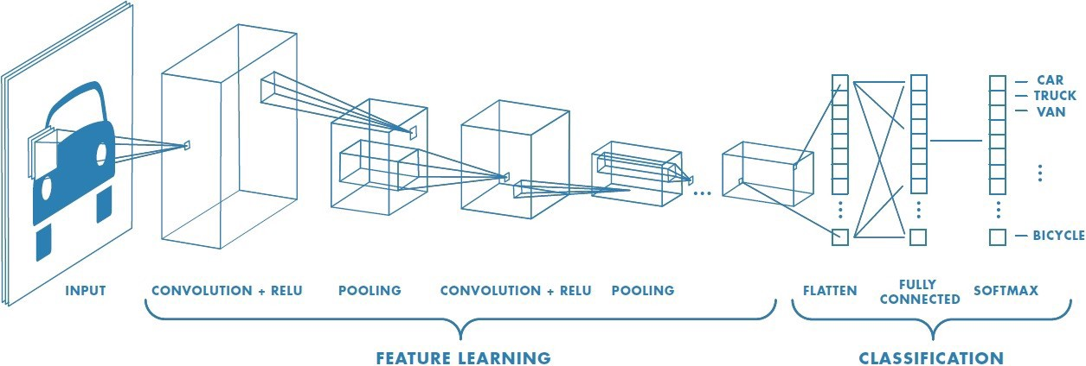

## 5.2 Exporting the Model to the Cloud

The model generated after CNN is transferred to cloud (AZURE) and configuration is done through SSH.

**→ Connecting to server:**

**$ ssh -X** *<user Name>@<IP address>*

*$ ssh -X Attendannce@192.178.43.71*

**→ Pushing the Model to the Cloud:**

**$ scp** *<file name> <use Name>@<server ip>:\root\<fileName>*

SSH provides a secure channel over an unsecured network by using a client–server architecture, connecting an SSH client application with an SSH server. The protocol specification distinguishes between two major versions, referred to as SSH-1 and SSH-2. The standard TCP port for SSH is 22. SSH is generally used to access Unix-like operating systems, but it can also be used on Microsoft Windows. Windows 10 uses OpenSSH as its default SSH client and SSH server SSH was designed as a replacement for Telnet and for unsecured remote shell protocols such as the Berkeley rsh and the related rlogin and rexec protocols. Those protocols send information, notably passwords, in plaintext, rendering them susceptible to interception and disclosure using packet analysis. The encryption used by SSH is intended to provide confidentiality and integrity of data over an unsecured network, such as the Internet.

**5.3 Using Dlib and Cmake for system compatibility**

Dlib is a modern C++ toolkit containing machine learning algorithms and tools for creating complex software in C++ to solve real world problems. It is used in both industry and academia in a wide range of domains including robotics, embedded devices, mobile phones, and large high performance computing environments. Dlib's [open source licensing](http://dlib.net/license.html) allows you to use it in any application, free of charge.

To follow or participate in the development of dlib subscribe to [dlib on github](https://github.com/davisking/dlib). Also be sure to read the [how to contribute](http://dlib.net/howto_contribute.html) page if you intend to submit code to the project.

**5.4 Connecting the cloud using Flask**

**Flask-SocketIO** gives Flask applications access to low latency bi-directional communications between the clients and the server. The client-side application can use any of the SocketIO official clients libraries in Javascript, C++, Java and Swift, or any compatible client to establish a permanent connection to the server.

**SYSTEM IMPLEMENTATION**

**CHAPTER 6**

**SYSTEM IMPLEMENTATION**

## 6.1 CODING-Model Training

def __init__(self):

pca = RandomizedPCA(n_components=150, whiten=True, random_state=42)

svc = SVC(kernel='rbf', class_weight='balanced')

self.model = make_pipeline(pca, svc)

param_grid = {'svc__C': [1, 5, 10, 50],

'svc__gamma': [0.0001, 0.0005, 0.001, 0.005]}

self.grid = GridSearchCV(self.model, param_grid)

def fit(self, X, y):

%time self.grid.fit(X, y)

print(self.grid.best_params_)

self.model = self.grid.best_estimator_

def predict(self, X):

return self.model.predict(X)

def plot_sample(self, target_names, y_hat):

fig, ax = plt.subplots(4, 6)

for i, axi in enumerate(ax.flat):

axi.imshow(X_test[i].reshape(62, 47), cmap='bone')

axi.set(xticks=[], yticks=[])

axi.set_ylabel(target_names[y_hat[i]].split()[-1],

color='black' if y_hat[i] == y_test[i] else 'red')

fig.suptitle('Predicted Names; Incorrect Labels in Red', size=14)

def report(self, target_names, y, y_hat):

print(classification_report(y, y_hat,

target_names=target_names))

def heatmap(self, target_names, y, y_hat):

mat = confusion_matrix(y, y_hat)

sns.heatmap(mat.T, square=True, annot=True, fmt='d', cbar=False,

xticklabels=target_names,

yticklabels=target_names)

plt.xlabel('true label')

plt.ylabel('predicted label')

# Analysis

y_hat = grid.predict(X_test)

grid.plot_sample(target_names, y_hat)

*VI. Analysed Report*

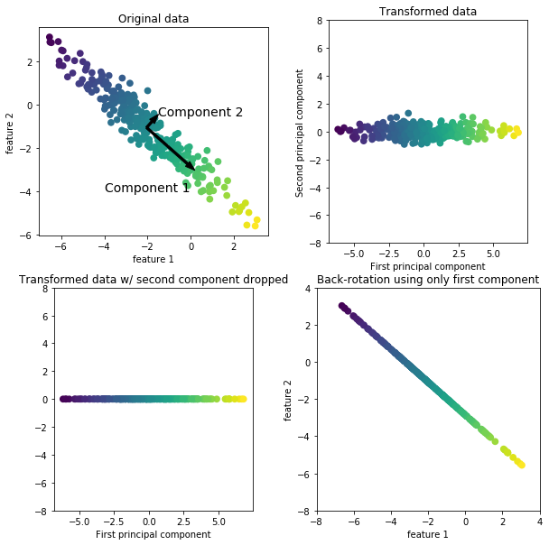

## 

## 6.2 Coding-Server side Scripting:

**I. Create an AWS Container.**

{

"containerDefinitions": [

{

"name": "container-using-efs",

"image": "amazonlinux:2",

"entryPoint": [

"sh",

"-c"

],

"command": [

"ls -la \mount\efs"

],

"mountPoints": [

{

"sourceVolume": "myEfsVolume",

"containerPath": "\mount\efs",

"readOnly": true

}

]

}

],

"volumes": [

{

"name": "myEfsVolume",

"efsVolumeConfiguration": {

"fileSystemId": "fs-1234",

"rootDirectory": "\path\to\my\data",

"transitEncryption": "ENABLED",

"transitEncryptionPort": integer,

"authorizationConfig": {

"accessPointId": "fsap-1234",

"iam": "ENABLED"

}

}

}

]

}

**II. Create an EFS push.**

*$ yum install amazon-efs-utils*

*$ systemctl enable --now amazon-ecs-volume-plugin*

## 6.3. coding-Dlib and Cmake script:

1. **Configuration file:**

if(NOT TARGET dlib-shared AND NOT dlib_BINARY_DIR)

# Compute paths

get_filename_component(dlib_CMAKE_DIR "${CMAKE_CURRENT_LIST_FILE}" PATH)

include("${dlib_CMAKE_DIR}/dlib.cmake")

endif()

set(dlib_LIBRARIES dlib::dlib)

set(dlib_LIBS dlib::dlib)

set(dlib_INCLUDE_DIRS "/usr/local/include" "")

mark_as_advanced(dlib_LIBRARIES)

mark_as_advanced(dlib_LIBS)

mark_as_advanced(dlib_INCLUDE_DIRS)

# Mark these variables above as deprecated.

function(__deprecated_var var access)

if(access STREQUAL "READ_ACCESS")

message(WARNING "The variable '${var}' is deprecated! Instead, simply use target_link_libraries(your_app dlib::dlib). See http://dlib.net/examples/CMakeLists.txt.html for an example.")

endif()

endfunction()

variable_watch(dlib_LIBRARIES __deprecated_var)

variable_watch(dlib_LIBS __deprecated_var)

variable_watch(dlib_INCLUDE_DIRS __deprecated_var)

1. **CMAKE :**

# Install script for directory: <directory>

# Set the install prefix

if(NOT DEFINED CMAKE_INSTALL_PREFIX)

set(CMAKE_INSTALL_PREFIX "/usr/local")

endif()

string(REGEX REPLACE "/$" "" CMAKE_INSTALL_PREFIX "${CMAKE_INSTALL_PREFIX}")

# Set the install configuration name.

if(NOT DEFINED CMAKE_INSTALL_CONFIG_NAME)

if(BUILD_TYPE)

string(REGEX REPLACE "^[^A-Za-z0-9_]+" ""

CMAKE_INSTALL_CONFIG_NAME "${BUILD_TYPE}")

else()

set(CMAKE_INSTALL_CONFIG_NAME "Release")

endif()

message(STATUS "Install configuration: \"${CMAKE_INSTALL_CONFIG_NAME}\"")

endif()

# Set the component getting installed.

if(NOT CMAKE_INSTALL_COMPONENT)

if(COMPONENT)

message(STATUS "Install component: \"${COMPONENT}\"")

set(CMAKE_INSTALL_COMPONENT "${COMPONENT}")

else()

set(CMAKE_INSTALL_COMPONENT)

endif()

endif()

# Install shared libraries without execute permission?

if(NOT DEFINED CMAKE_INSTALL_SO_NO_EXE)

set(CMAKE_INSTALL_SO_NO_EXE "1")

endif()

# Is this installation the result of a cross compile?

if(NOT DEFINED CMAKE_CROSSCOMPILING)

set(CMAKE_CROSSCOMPILING "FALSE")

endif()

# Set default install directory permissions.

if(NOT DEFINED CMAKE_OBJDUMP)

set(CMAKE_OBJDUMP "/usr/bin/objdump")

endif()

if("x${CMAKE_INSTALL_COMPONENT}x" STREQUAL "xUnspecifiedx" OR NOT CMAKE_INSTALL_COMPONENT)

file(INSTALL DESTINATION "${CMAKE_INSTALL_PREFIX}/lib" TYPE STATIC_LIBRARY FILES "/home/humanz/Desktop/Tcs_handson/Flask_proj/Attendance_system_flask/dlib/build/dlib/libdlib.a")

endif()

if("x${CMAKE_INSTALL_COMPONENT}x" STREQUAL "xUnspecifiedx" OR NOT CMAKE_INSTALL_COMPONENT)

file(INSTALL DESTINATION "${CMAKE_INSTALL_PREFIX}/include/dlib" TYPE DIRECTORY FILES "/home/humanz/Desktop/Tcs_handson/Flask_proj/Attendance_system_flask/dlib/dlib/" FILES_MATCHING REGEX "/[^/]*\\.h$" REGEX "/[^/]*\\.cmake$" REGEX "/[^/]*\\_tutorial\\.txt$" REGEX "/cassert$" REGEX "/cstring$" REGEX "/fstream$" REGEX "/iomanip$" REGEX "/iosfwd$" REGEX "/iostream$" REGEX "/istream$" REGEX "/locale$" REGEX "/ostream$" REGEX "/sstream$" REGEX "/home/humanz/Desktop/Tcs_handson/Flask_proj/Attendance_system_flask/dlib/build/dlib" EXCLUDE)

endif()

if("x${CMAKE_INSTALL_COMPONENT}x" STREQUAL "xUnspecifiedx" OR NOT CMAKE_INSTALL_COMPONENT)

file(INSTALL DESTINATION "${CMAKE_INSTALL_PREFIX}/include/dlib" TYPE FILE FILES "/home/humanz/Desktop/Tcs_handson/Flask_proj/Attendance_system_flask/dlib/build/dlib/config.h")

endif()

if("x${CMAKE_INSTALL_COMPONENT}x" STREQUAL "xUnspecifiedx" OR NOT CMAKE_INSTALL_COMPONENT)

file(INSTALL DESTINATION "${CMAKE_INSTALL_PREFIX}/include/dlib" TYPE FILE FILES "/home/humanz/Desktop/Tcs_handson/Flask_proj/Attendance_system_flask/dlib/build/dlib/revision.h")

endif()

if("x${CMAKE_INSTALL_COMPONENT}x" STREQUAL "xUnspecifiedx" OR NOT CMAKE_INSTALL_COMPONENT)

if(EXISTS "$ENV{DESTDIR}${CMAKE_INSTALL_PREFIX}/lib/cmake/dlib/dlib.cmake")

file(DIFFERENT EXPORT_FILE_CHANGED FILES

"$ENV{DESTDIR}${CMAKE_INSTALL_PREFIX}/lib/cmake/dlib/dlib.cmake"

"/home/humanz/Desktop/Tcs_handson/Flask_proj/Attendance_system_flask/dlib/build/dlib/CMakeFiles/Export/lib/cmake/dlib/dlib.cmake")

if(EXPORT_FILE_CHANGED)

file(GLOB OLD_CONFIG_FILES "$ENV{DESTDIR}${CMAKE_INSTALL_PREFIX}/lib/cmake/dlib/dlib-*.cmake")

if(OLD_CONFIG_FILES)

message(STATUS "Old export file \"$ENV{DESTDIR}${CMAKE_INSTALL_PREFIX}/lib/cmake/dlib/dlib.cmake\" will be replaced. Removing files [${OLD_CONFIG_FILES}].")

file(REMOVE ${OLD_CONFIG_FILES})

endif()

endif()

endif()

file(INSTALL DESTINATION "${CMAKE_INSTALL_PREFIX}/lib/cmake/dlib" TYPE FILE FILES "/home/humanz/Desktop/Tcs_handson/Flask_proj/Attendance_system_flask/dlib/build/dlib/CMakeFiles/Export/lib/cmake/dlib/dlib.cmake")

if("${CMAKE_INSTALL_CONFIG_NAME}" MATCHES "^([Rr][Ee][Ll][Ee][Aa][Ss][Ee])$")

file(INSTALL DESTINATION "${CMAKE_INSTALL_PREFIX}/lib/cmake/dlib" TYPE FILE FILES "/home/humanz/Desktop/Tcs_handson/Flask_proj/Attendance_system_flask/dlib/build/dlib/CMakeFiles/Export/lib/cmake/dlib/dlib-release.cmake")

endif()

endif()

if("x${CMAKE_INSTALL_COMPONENT}x" STREQUAL "xUnspecifiedx" OR NOT CMAKE_INSTALL_COMPONENT)

file(INSTALL DESTINATION "${CMAKE_INSTALL_PREFIX}/lib/cmake/dlib" TYPE FILE FILES

"/home/humanz/Desktop/Tcs_handson/Flask_proj/Attendance_system_flask/dlib/build/dlib/config/dlibConfig.cmake"

"/home/humanz/Desktop/Tcs_handson/Flask_proj/Attendance_system_flask/dlib/build/dlib/config/dlibConfigVersion.cmake"

)

endif()

if("x${CMAKE_INSTALL_COMPONENT}x" STREQUAL "xUnspecifiedx" OR NOT CMAKE_INSTALL_COMPONENT)

file(INSTALL DESTINATION "${CMAKE_INSTALL_PREFIX}/lib/pkgconfig" TYPE FILE FILES "/home/humanz/Desktop/Tcs_handson/Flask_proj/Attendance_system_flask/dlib/build/dlib/dlib-1.pc")

endif()

## 

## 6.4 Coding HTML and Flask Script:

1. **Setting user Environment:**

import os

import re

import sys

import shutil

import platform

import subprocess

import multiprocessing

from distutils import log

from math import ceil,floor

from setuptools import setup, Extension

from setuptools.command.build_ext import build_ext

from distutils.version import LooseVersion

def get_extra_cmake_options():

"""read --clean, --no, --set, --compiler-flags, and -G options from the command line and add them as cmake switches.

"""

_cmake_extra_options = []

_clean_build_folder = False

opt_key = None

argv = [arg for arg in sys.argv] # take a copy

# parse command line options and consume those we care about

for arg in argv:

if opt_key == 'compiler-flags':

_cmake_extra_options.append('-DCMAKE_CXX_FLAGS={arg}'.format(arg=arg.strip()))

elif opt_key == 'G':

_cmake_extra_options += ['-G', arg.strip()]

elif opt_key == 'no':

_cmake_extra_options.append('-D{arg}=no'.format(arg=arg.strip()))

elif opt_key == 'set':

_cmake_extra_options.append('-D{arg}'.format(arg=arg.strip()))

if opt_key:

sys.argv.remove(arg)

opt_key = None

continue

if arg == '--clean':

_clean_build_folder = True

sys.argv.remove(arg)

continue

if arg == '--yes':

print("The --yes options to dlib's setup.py don't do anything since all these options ")

print("are on by default. So --yes has been removed. Do not give it to setup.py.")

sys.exit(1)

if arg in ['--no', '--set', '--compiler-flags']:

opt_key = arg[2:].lower()

sys.argv.remove(arg)

continue

if arg in ['-G']:

opt_key = arg[1:]

sys.argv.remove(arg)

continue

return _cmake_extra_options, _clean_build_folder

cmake_extra_options,clean_build_folder = get_extra_cmake_options()

class CMakeExtension(Extension):

def __init__(self, name, sourcedir=''):

Extension.__init__(self, name, sources=[])

self.sourcedir = os.path.abspath(sourcedir)

def rmtree(name):

"""remove a directory and its subdirectories.

"""

def remove_read_only(func, path, exc):

excvalue = exc[1]

if func in (os.rmdir, os.remove) and excvalue.errno == errno.EACCES:

os.chmod(path, stat.S_IRWXU | stat.S_IRWXG | stat.S_IRWXO)

func(path)

else:

raise

if os.path.exists(name):

log.info('Removing old directory {}'.format(name))

shutil.rmtree(name, ignore_errors=False, onerror=remove_read_only)

class CMakeBuild(build_ext):

def get_cmake_version(self):

try:

out = subprocess.check_output(['cmake', '--version'])

except:

sys.stderr.write("\nERROR: CMake must be installed to build dlib\n\n")

sys.exit(1)

return re.search(r'version\s*([\d.]+)', out.decode()).group(1)

def run(self):

cmake_version = self.get_cmake_version()

if platform.system() == "Windows":

if LooseVersion(cmake_version) < '3.1.0':

sys.stderr.write("\nERROR: CMake >= 3.1.0 is required on Windows\n\n")

sys.exit(1)

for ext in self.extensions:

self.build_extension(ext)

def build_extension(self, ext):

extdir = os.path.abspath(os.path.dirname(self.get_ext_fullpath(ext.name)))

cmake_args = ['-DCMAKE_LIBRARY_OUTPUT_DIRECTORY=' + extdir,

'-DPYTHON_EXECUTABLE=' + sys.executable]

cmake_args += cmake_extra_options

cfg = 'Debug' if self.debug else 'Release'

build_args = ['--config', cfg]

if platform.system() == "Windows":

cmake_args += ['-DCMAKE_LIBRARY_OUTPUT_DIRECTORY_{}={}'.format(cfg.upper(), extdir)]

if sys.maxsize > 2**32:

cmake_args += ['-A', 'x64']

# Do a parallel build

build_args += ['--', '/m']

else:

cmake_args += ['-DCMAKE_BUILD_TYPE=' + cfg]

# Do a parallel build

build_args += ['--', '-j'+str(num_available_cpu_cores(2))]

build_folder = os.path.abspath(self.build_temp)

if clean_build_folder:

rmtree(build_folder)

if not os.path.exists(build_folder):

os.makedirs(build_folder)

cmake_setup = ['cmake', ext.sourcedir] + cmake_args

cmake_build = ['cmake', '--build', '.'] + build_args

print("Building extension for Python {}".format(sys.version.split('\n',1)[0]))

print("Invoking CMake setup: '{}'".format(' '.join(cmake_setup)))

sys.stdout.flush()

subprocess.check_call(cmake_setup, cwd=build_folder)

print("Invoking CMake build: '{}'".format(' '.join(cmake_build)))

sys.stdout.flush()

subprocess.check_call(cmake_build, cwd=build_folder)

def num_available_cpu_cores(ram_per_build_process_in_gb):

if 'TRAVIS' in os.environ and os.environ['TRAVIS']=='true':

# When building on travis-ci, just use 2 cores since travis-ci limits

# you to that regardless of what the hardware might suggest.

return 2

try:

mem_bytes = os.sysconf('SC_PAGE_SIZE') * os.sysconf('SC_PHYS_PAGES')

mem_gib = mem_bytes/(1024.**3)

num_cores = multiprocessing.cpu_count()

# make sure we have enough ram for each build process.

mem_cores = int(floor(mem_gib/float(ram_per_build_process_in_gb)+0.5));

# We are limited either by RAM or CPU cores. So pick the limiting amount

# and return that.

return max(min(num_cores, mem_cores), 1)

except ValueError:

return 2 # just assume 2 if we can't get the os to tell us the right answer.

from setuptools.command.test import test as TestCommand

class PyTest(TestCommand):

user_options = [('pytest-args=', 'a', "Arguments to pass to pytest")]

def initialize_options(self):

TestCommand.initialize_options(self)

self.pytest_args = '--ignore docs --ignore dlib'

def run_tests(self):

import shlex

#import here, cause outside the eggs aren't loaded

import pytest

errno = pytest.main(shlex.split(self.pytest_args))

sys.exit(errno)

def read_version_from_cmakelists(cmake_file):

"""Read version information

"""

major = re.findall("set\(CPACK_PACKAGE_VERSION_MAJOR.*\"(.*)\"", open(cmake_file).read())[0]

minor = re.findall("set\(CPACK_PACKAGE_VERSION_MINOR.*\"(.*)\"", open(cmake_file).read())[0]

patch = re.findall("set\(CPACK_PACKAGE_VERSION_PATCH.*\"(.*)\"", open(cmake_file).read())[0]

return major + '.' + minor + '.' + patch

def read_entire_file(fname):

"""Read text out of a file relative to setup.py.

"""

return open(os.path.join(fname)).read()

setup(

name='dlib',

version=read_version_from_cmakelists('dlib/CMakeLists.txt'),

description='A toolkit for making real world machine learning and data analysis applications',

long_description='See http://dlib.net for documentation.',

author='Davis King',

author_email='davis@dlib.net',

url='https://github.com/davisking/dlib',

license='Boost Software License',

ext_modules=[CMakeExtension('_dlib_pybind11','tools/python')],

cmdclass=dict(build_ext=CMakeBuild, test=PyTest),

zip_safe=False,

# We need an older more-itertools version because v6 broke pytest (for everyone, not just dlib)

tests_require=['pytest==3.8', 'more-itertools<6.0.0'],

#install_requires=['cmake'], # removed because the pip cmake package is busted, maybe someday it will be usable.

packages=['dlib'],

package_dir={'': 'tools/python'},

keywords=['dlib', 'Computer Vision', 'Machine Learning'],

classifiers=[

'Development Status :: 5 - Production/Stable',

'Intended Audience :: Science/Research',

'Intended Audience :: Developers',

'Operating System :: MacOS :: MacOS X',

'Operating System :: POSIX',

'Operating System :: POSIX :: Linux',

'Operating System :: Microsoft',

'Operating System :: Microsoft :: Windows',

'Programming Language :: C++',

'Programming Language :: Python',

'Programming Language :: Python :: 2',

'Programming Language :: Python :: 2.6',

'Programming Language :: Python :: 2.7',

'Programming Language :: Python :: 3',

'Programming Language :: Python :: 3.4',

'Programming Language :: Python :: 3.5',

'Programming Language :: Python :: 3.6',

'Topic :: Scientific/Engineering',

'Topic :: Scientific/Engineering :: Artificial Intelligence',

'Topic :: Scientific/Engineering :: Image Recognition',

'Topic :: Software Development',

],

)

**Flask Code:**

#---------------------------Define Global Attendance Dictionary--------------------

def Initial_set():

for names in known_face_names:

student_attendance[names]=[[0,0,0],"absent"]

# Set Unknown intimation for error correction (Faces)

student_attendance["Unknown"]=[[0,0,0],"absent"]

Initial_set()

#catch previous instance

student_attendance_pre = student_attendance

#---------------------------attach Zoom - Teams - Meet content from server as data----------------

def capture_session_screen():

# Initialize some variables

face_locations = []

face_encodings = []

face_names = []

process_this_frame = True

video_capture = cv2.VideoCapture(1)

ret, frame = video_capture.read()

# Resize frame of video to 1/4 size for faster face recognition processing

small_frame = cv2.resize(frame, (0, 0), fx=0.25, fy=0.25)

# Convert the image from BGR color (which OpenCV uses) to RGB color (which face_recognition uses)

rgb_small_frame = small_frame[:, :, ::-1]

# Only process every other frame of video to save time

if process_this_frame:

# Find all the faces and face encodings in the current frame of video

face_locations = face_recognition.face_locations(rgb_small_frame)

face_encodings = face_recognition.face_encodings(rgb_small_frame, face_locations)

face_names = []

for face_encoding in face_encodings:

# See if the face is a match for the known face(s)

matches = face_recognition.compare_faces(known_face_encodings, face_encoding)

name = "Unknown"

# # If a match was found in known_face_encodings, just use the first one.

# if True in matches:

# first_match_index = matches.index(True)

# name = known_face_names[first_match_index]

# Or instead, use the known face with the smallest distance to the new face

face_distances = face_recognition.face_distance(known_face_encodings, face_encoding)

best_match_index = np.argmin(face_distances)

if matches[best_match_index]:

name = known_face_names[best_match_index]

face_names.append(name)

process_this_frame = not process_this_frame

# Display the results

for (top, right, bottom, left), name in zip(face_locations, face_names):

# Scale back up face locations since the frame we detected in was scaled to 1/4 size

top *= 4

right *= 4

bottom *= 4

left *= 4

# Draw a box around the face

cv2.rectangle(frame, (left, top), (right, bottom), (0, 0, 255), 2)

# Draw a label with a name below the face

cv2.rectangle(frame, (left, bottom - 35), (right, bottom), (0, 0, 255), cv2.FILLED)

font = cv2.FONT_HERSHEY_DUPLEX

cv2.putText(frame, name, (left + 6, bottom - 6), font, 1.0, (255, 255, 255), 1)

# Display the resulting image

frame=cv2.resize(frame,(960,540))

#cv2.imshow('Video', frame)

# Hit 'q' on the keyboard to quit!

#if cv2.waitKey(1) & 0xFF == ord('q'):

# break

name_set=set(face_names)

print(name_set)

#break

# Release handle to the webcam

video_capture.release()

#cv2.destroyAllWindows()

#cv2.waitKey(0)

return name_set

#-------------Mark Attendance--------------------------------

def mark_attendance(count):

print("hello you called me !",count)

# Get Name set of attended students.

name_set=capture_session_screen()

# Iterate over Names and mark attendance

for name in name_set:

student_attendance[name][0][count]=1

if sum(student_attendance[name][0])>=2:

student_attendance[name][1]="present"

student_attendance_pre = student_attendance

#-------------Marked Attendance-------------------------------

#create a route

@app.route('/')

def home():

Initial_set()

return render_template('index.html')

@app.route('/attendance',methods=['GET','POST'])

def result():

if request.method == 'POST':

flash(" ".join(request.form.keys()))

flash(" ".join(request.form.values()))

duration = float(request.form["duration"])*60

delay = duration/3

print(duration,delay)

count = 2

while count>-1:

#start_time = threading.Timer(120.0,mark_attendance(count))#.start()

#start_time.start()

time.sleep(delay)

print("attendance marking started",count)

mark_attendance(count)

count-=1

#flash(student_attendance)

#print(request.form.keys())

#f=request.form['img_file'].split("/")

#-----------------------------------#

#result=jsonify(l.predict(f)) #

#json.dump(result,"testfile.json") #

#-----------------------------------#

#with open("testfile.json") as jfile:

# dicl=json.load(jfile)

#ifile=f[len(f)-1]

#if ifile in dicl.keys():

# result=dicl[ifile]

#furl="/test_images/"+f[len(f)-1]

#attendance=student_attendance.values(),

return render_template('index.html',isindex=True,len=len(student_attendance),attendance=list(student_attendance.values()),names=list(student_attendance.keys()))

#return jsonify(student_attendance)

else:

return render_template('index.html',isindex=True,len=len(student_attendance_pre),attendance=list(student_attendance_pre.values()),names=list(student_attendance_pre.keys()))

#return redirect(url_for('home'))

@app.route('/api')

def model():

return jsonify(student_attendance)

**HTML and Jinja:**

<!DOCTYPE html>

<html>

<head>

<!--- style sheets -->

<link rel="stylesheet" href="https://stackpath.bootstrapcdn.com/bootstrap/4.4.1/css/bootstrap.min.css" integrity="sha384-Vkoo8x4CGsO3+Hhxv8T/Q5PaXtkKtu6ug5TOeNV6gBiFeWPGFN9MuhOf23Q9Ifjh" crossorigin="anonymous">

<!---------Custom css and js-------------------->

<!-- other tags-->

<meta charset='utf-8'>

<meta http-equiv='X-UA-Compatible' content='IE=edge'>

<title> &#127895; Smart class Monitoring system</title>

<meta name="viewport" content="width=device-width, initial-scale=1, shrink-to-fit=no">

</head>

<body style="background-color:beige">

<center>

{% if isindex %}

<!--

###{% with message = get_flashed_messages() %}

##{% if message %}

## <p>{{ message }}</p>

##{% endif %}

##{% endwith %}-->

<!--<p>#{{ attendance }}</p>

<p>#{{ names[0] }}</p>

<p>#{{len}}</p>-->

<table border="1" class="table table-striped table-light table-responsive table-hover" style="width: 75%;margin-top: 5%;">

<thead class="thead-dark">

<tr style="text-align: right;">

<th>Name</th>

<th>Attendance1</th>

<th>Attendance2</th>

<th>Attendance3</th>

<th>Grand Attendance</th>

</tr>

</thead>

<tbody>

{%for i in range(0, len)%}

<tr>

<th>{{names[i]}}</th>

<td>{{attendance[i][0][0]}}</td>

<td>{{attendance[i][0][1]}}</td>

<td>{{attendance[i][0][2]}}</td>

<th>{{attendance[i][1]}}</th>

</tr>

{%endfor%}

</tbody>

</table>

{% else %}

<div class="bd-callout bd-callout-info" style="margin-top: 5%; width: 70%; text-align: left;padding: .50rem;padding-top: .25rem; border: 1px solid #eee;border-left-width: .25rem;

border-radius: .25rem;border-left-color: #5bc0de;">

<h4> Online Class Monitoring system </h4>

<p>

Enter Duration of Session in <b>(minutes)</b> and number of attendies as (Integer)

</p>

</div>

<div class="jumbotron shadow-lg rounded" style="width: 85%; margin-top: 2%;padding-top: 1%; padding-bottom: 1%;background-color: rgb(209, 207, 204);">

<form action="attendance" class="form-horizontal" enctype="multipart/form-data" method="POST" >

<div class="form-group">

<label for="duration" class="control-label col-sm-3"> Duration <i>(in minutes)</i>: </label>

<input type="text" name="duration" id="duration" value="0">

<label for="attendies" class="control-label col-sm-3"> No of Attendies : </label>

<input type="number" name="attendies" id="attendies" min="1" max="5">

</div>

<input type="submit" class="btn col-sm-2" name="submit" value="Monitor" style="border-color: black; font-size: x-large; border-radius: 20%;" >

</form>

</div>

{% endif %}

</center>

</body>

</html>

**SYSTEM TESTING**

**CHAPTER 7**

**SYSTEM TESTING**

**7.1.1 GENERAL**

Software testing is a crucial element of software quality assurance and represents the ultimate review of specification, design and coding. In fact, testing is the one step in the software engineering process that could be viewed as destructive rather than constructive. A strategy for software testing integrates software test case design methods as a well-planned series of steps that result in the successful construction of the software. Testing is the set of activities that can be planned in advance and structured systematically. The underlying motivation of program testing is to affirm software quality with methods that can economically and effectively and strategically apply to both large and small-scale systems.

**7.1.2 STRATEGIC APPROACH TO SOFTWARE TESTING**

The software engineering process can be viewed as a spiral. Initially system engineering defines the role of software and leads to software requirement analysis where the information domain, functions, behaviour, performance, constraints and validation criteria for software are established. Moving inward along the spiral, we come to design and finally to coding. To develop computer software we spiral in along streamlines to decrease the level of abstraction on each turn. A strategy for software testing may also be viewed in the context of the spiral. Unit testing begins at the vertex of the spiral and concentrates on each unit of the software as implemented in the source code. Testing progress by moving outward along the spiral to integration testing, where the focus is on the design and the construction of the software architecture. Taking another turn outward on the spiral we encounter validation testing where requirements established as part of software requirements 44analysis are validated against the software that has been constructed. Finally we arrive at system testing, where the software and other system elements are tested as a whole.

**7.2 TYPES OF TESTING**

**7.2.1. UNIT TESTING**

Unit testing focuses verification effort on the smallest unit of the software design, the module. The unit testing we have is white box oriented and some modules are conducted in parallel.

**7.2.2 WHITE BOX TESTING**

This testing ensures that

● All independent paths have been exercised at least once.

● All logical decisions have been exercised on their true and false sides.

● All loops are executed at their boundaries and within their operational bounds.

● All internal data structures have been exercised to assure their validity. To follow the concept of white box testing we have tested each form. We have created independently to verify that Data flow is correct, all conditions are exercised to check their validity, all loops are executed on their boundaries.

**7.2.3 BASIC PATH TESTING**

Established technique of flow graph with Cyclomatic complexity was used to derive test cases for all the functions.

The main steps for deriving the test cases were:

● Using the design on the code draw the corresponding flow graph.

● Determine the Cyclomatic complexity of the resultant flow graph, using formula:

V(G) = E – N + 2 or V (G) = P + 1 or 45

V (G) = Number of Regions Where V (G) is Cyclomatic complexity,

E is the number of edges, N is the number of flow graph nodes,

P is the number of predicate nodes.

From this we determine the basis of a set of linearly independent paths.

**7.2.4 CONDITIONAL TESTING**

In this part of testing each of the conditions were tested to both true and false aspects and all the resulting paths were tested .So that each path that may be generated on particular condition is traced to uncover any possible errors.

**7.2.5.DATA FLOW TESTING**

This type of testing selects the path of the program according to the location of definition and use of variables. This type of testing is used only when some local variables are declared. The definition-use chain method was used in this type of testing. These were particularly useful in nested statements.

**7.2.6 LOOP TESTING**

In this type of testing all the loops are tested to all the limits possible. The following exercise was adopted for all the loops:

● All the loops were tested at their limits, just above them and just below them.

● All the loops were skipped at least once.

● For nested loops test the inner most loop first and then work outwards.

● For concatenated loops the values of dependent loops were set with the help of connected loops.

● Unstructured loops were resolved into nested loops or concatenated loops and tested as above.

**7.3.TEST CASES AND REPORTS**

The following are some of the important test cases that are to be run to ensure smooth functioning of the system.

.Facial Detection:

|  |  |  |  |  |  |
| --- | --- | --- | --- | --- | --- |
| **HOST ID** | **MODULE NAME** | **INPUT** | **EXPECTED OUTPUT** | **ACTUAL OUTPUT** | **REMARKS** |
| **TC01** | Facial Recognition module | Registered faces | Detection of the face with the name of the person. | Pass | Module works as expected. |
| **TC02** | Facial Recognition module | Unregistered faces | Detection of the face with the message as an unknown person. | Pass | The face of the unknown person can be registered in the database to get better results. |

**CONCLUSION**

**CHAPTER 8**

**8.1 CONCLUSION:**

The Main Objective of this project is to reduce the burden/Work that is carried out manually for taking attendance by replacing it with a Smart attendance system using Facial Recognition. It takes barely 3 seconds to recognize your face and create an attendance journal in the payroll system, saving precious man-hours. Automatically scans multiple students, with 99.8% accuracy in face detection. Faces once recognised are accurately enrolled into the payroll system. Integrated with systems like loT sensors, it cannot be scammed easily. Saving time will lead to an increase in productivity, resulting in reduction of cost (optimal utilization of resources) and an increase in revenue

**8.2 FUTURE SCOPE:**

The future work involves building of a complete application or as a plugin for other applications inclusive of much more additional features. Which makes monitoring and attendance work more simple.

**APPENDICES**

**APPENDICES**

**A.1 SAMPLE SCREENSHOTS:**

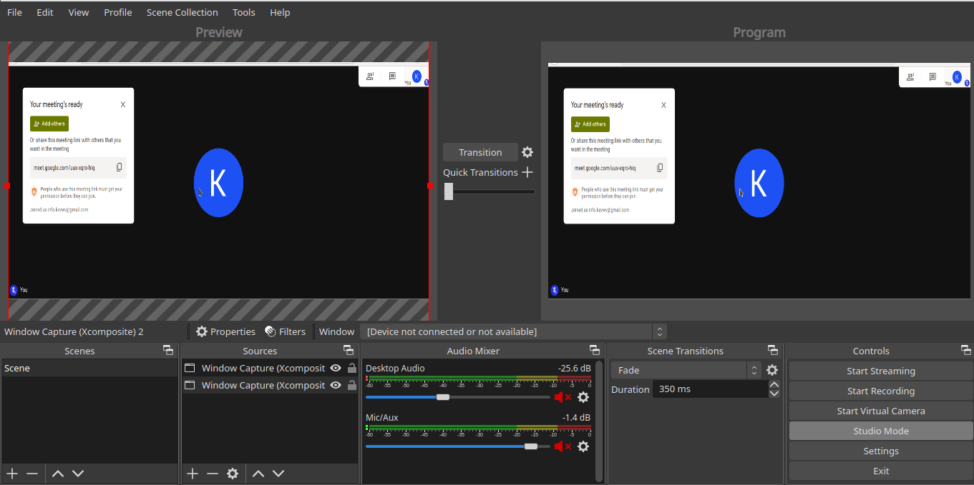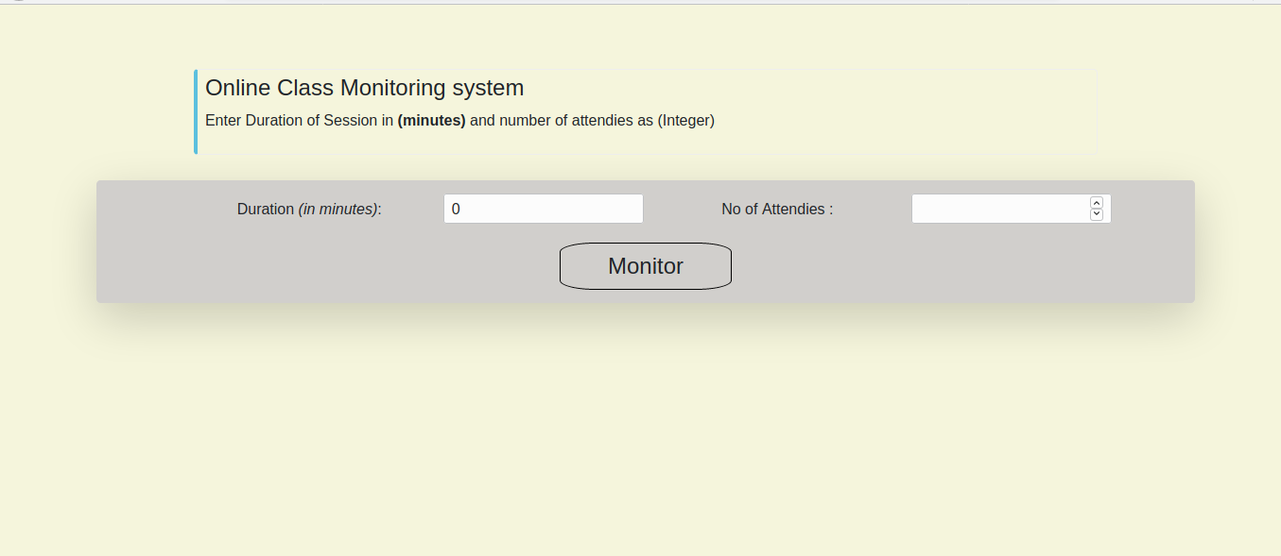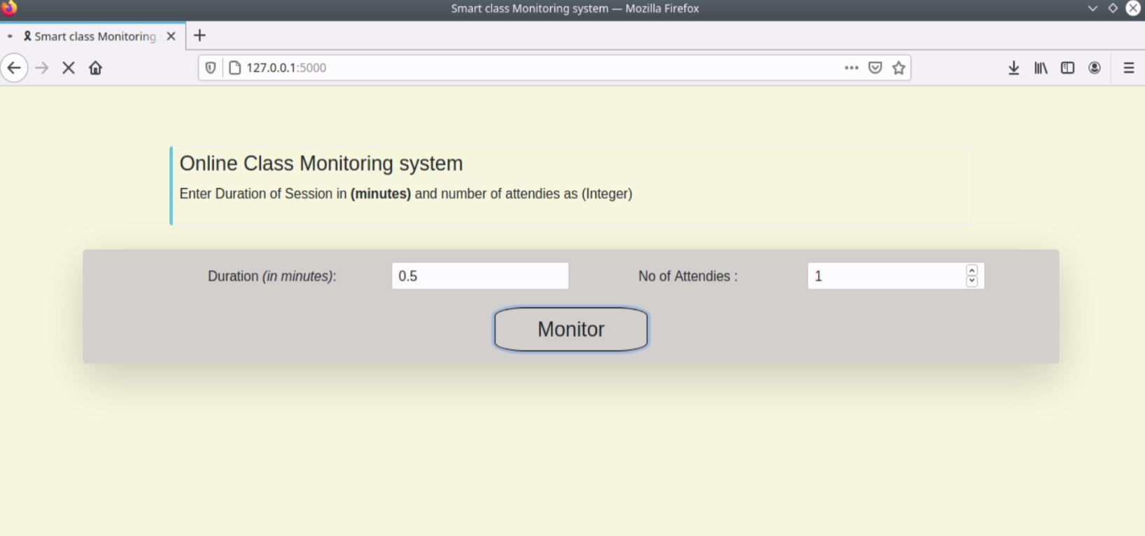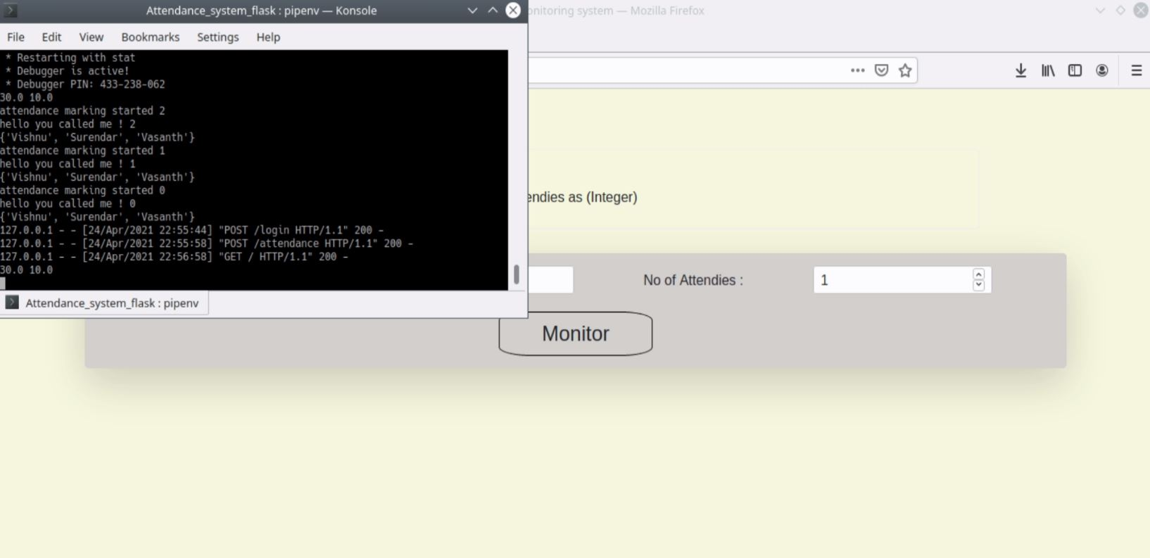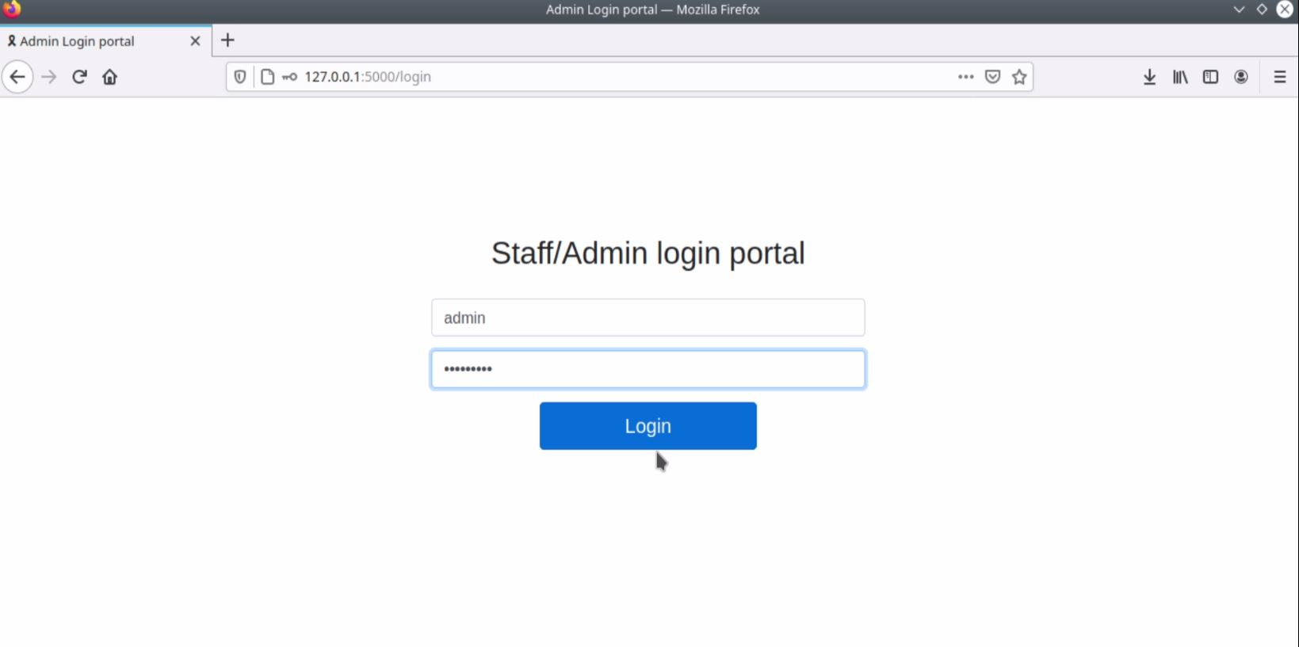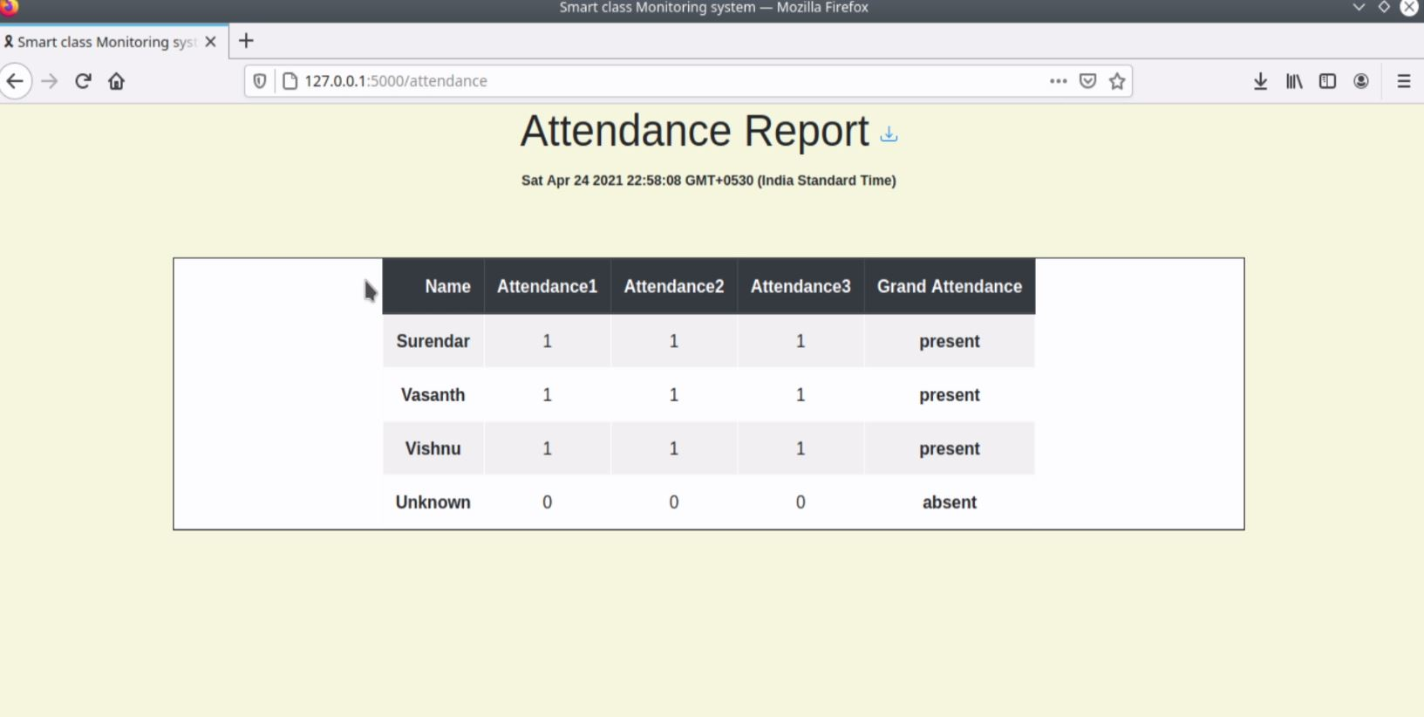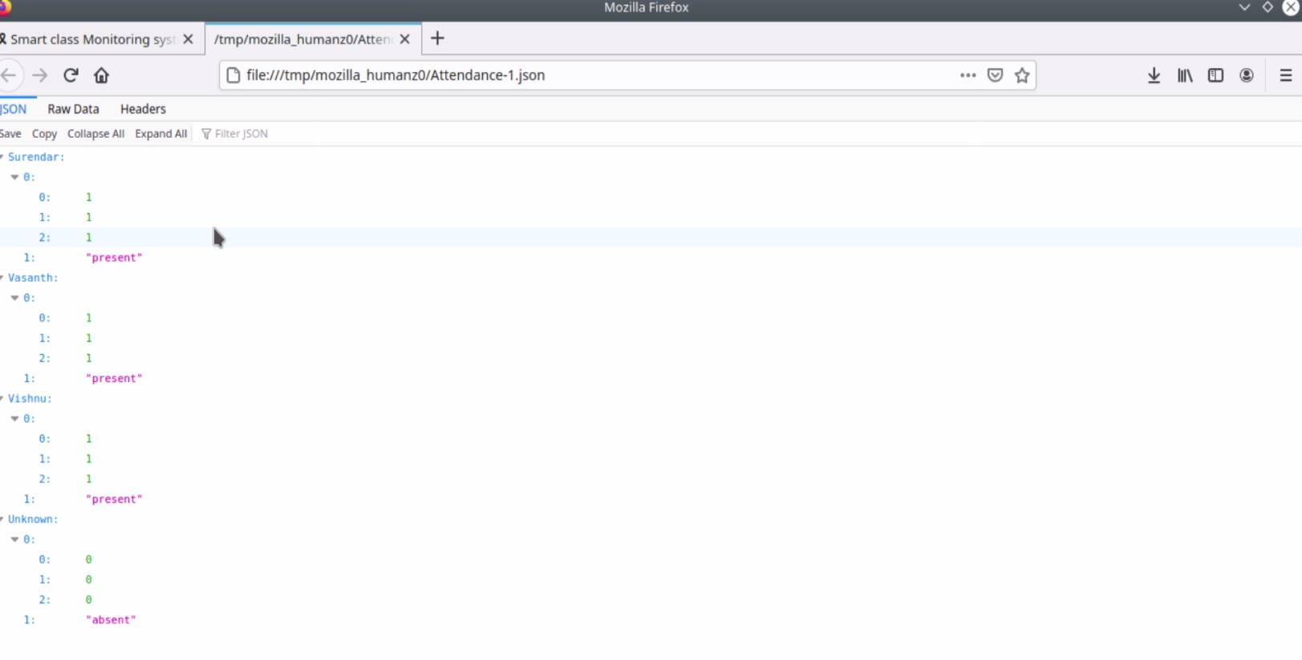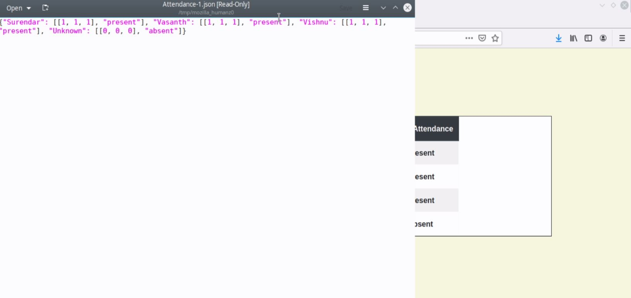

**REFERENCES:**

[1] https://www.researchgate.net/publication/326261079_Face_detection_

system_for_attendance_of_class’_students

[2] Hapani, Smit, et al. "Automated Attendance System Using Image

Processing." 2018 Fourth International Conference on Computing

Communication Control and Automation (ICCUBEA). IEEE, 2018.

[3] Akbar, Md Sajid, et al. "Face Recognition and RFID Verified

Attendance System." 2018 International Conference on Computing,

Electronics & Communications Engineering (iCCECE). IEEE, 2018.

[4] Okokpujie, Kennedy O., et al. "Design and implementation of a

student attendance system using iris biometric recognition." 2017

International Conference on Computational Science and

Computational Intelligence (CSCI). IEEE, 2017.

[5] Rathod, Hemantkumar, et al. "Automated attendance system using

machine learning approach." 2017 International Conference on

Nascent Technologies in Engineering (ICNTE). IEEE, 2017.

[6] Siswanto, Adrian Rhesa Septian, Anto Satriyo Nugroho, and

Maulahikmah Galinium. "Implementation of face recognition

algorithm for biometrics based time attendance system." 2014

International Conference on ICT For Smart Society (ICISS). IEEE,

2014.

[7] Lukas, Samuel, et al. "Student attendance system in classroom using

face recognition technique." 2016 International Conference on

Information and Communication Technology Convergence (ICTC).

IEEE, 2016.

[8] https://becominghuman.ai/face-detection-using-opencv-with-haar-

cascade-classifiers-941dbb25177

[9] https://www.superdatascience.com/blogs/opencv-face-recognition

[10] Salim, Omar Abdul Rhman, Rashidah Funke Olanrewaju, and Wasiu

Adebayo Balogun. "Class attendance management system using face

recognition." 2018 7th International Conference on Computer and

Communication Engineering (ICCCE). IEEE, 2018.